Automation Platform Integration
  - With CyberArk’s Dynamic Access Provider (DAP)

Table of Contents
Red Hat Ansible Engine & Ansible project 1
Lookup Plugin – conjur_variable 1
Requirements 1
Parameters 2
Usage Examples 2
Role – conjur-host-identity 3
Requirements 3
Installation 3
Role Variables 3
Usage Examples 3
Red Hat Ansible Tower 4
Secrets Management System Lookup – CyberArk Conjur Secret Lookup 4
Requirements 4
Configuration 4

Red Hat Ansible Engine & Ansible project

Lookup Plugin – conjur_variable
Using the lookup plugin conjur_variable in your playbook allows you to securely retrieve secrets from Dynamic Access Provider (DAP) at task run time.

Requirements
- Ansible v2.5 or above.
- The Ansible controller must have a host identity from DAP.
- The DAP config file (conjur.conf) and the DAP identity file (conjur.identity) should be located in /etc/ on the Ansible controller.
- Network access from Ansible controller to DAP instance.
Note: Environment variable delivery of the host identity values from DAP to the lookup plugin is not supported.

Parameters
- config_file
  - Default: /etc/conjur.conf
  - Variable Name: CONJUR_CONFIG_FILE
- identity_file
  - Default: /etc/conjur.identity
  - Variable Name: CONJUR_IDENTITY_FILE

Usage Examples

Common Usage Example
---
- name: conjur_variable Common Usage Example
hosts: all

tasks:

- name: Retrieve secret from Dynamic Access Provider (DAP)
set_fact:
conjur_response: "{{ lookup('conjur_variable', '/path/to/secret') }}"
no_log: yes

- name: Print secret to output (Don't do this except for testing purposes)
debug:
msg: "{{ conjur_response }}"

Non-Default Host Identity File Paths
---
- name: conjur_variable Non-Default Host Identity File Paths
hosts: all
vars:
CONJUR_CONFIG_FILE: /user/awx/conjur.conf
CONJUR_IDENTITY_FILE: /user/awx/conjur.identity

tasks:

- name: Retrieve secret from Dynamic Access Provider (DAP)
set_fact:
conjur_response: "{{ lookup('conjur_variable', '/path/to/secret') }}"
no_log: yes

- name: Print secret to output (Don't do this except for testing purposes)
debug:
msg: "{{ conjur_response }}"

Role – conjur-host-identity
Using the Role conjur-host-identity allows simple DAP host identity creation & deployment onto target nodes. This also includes deployment of Summon and Summon-Conjur provider onto the target node.

Requirements
- Ansible 2.3 or above.
- EL 7, Ubuntu Trusty (14.04), Ubuntu Xenial (16.04)
- Network access from target node to DAP instance.

Installation
ansible-galaxy install cyberark.conjur-host-identity

Role Variables
- conjur_appliance_url*
  - URL of the running DAP instance.
- conjur_account*
  - DAP account name.
- conjur_host_factory_token*
  - Host Factory token for target node grant to layer role.
  - This should be an environment variable on the Ansible controller.
- conjur_host_name*
  - Name of the host being granted DAP host identity.
- conjur_ssl_certificate*
  - Public SSL certificate of the DAP instance.
- conjur_validate_certs
  - Boolean value to indicate if the DAP instance should validate certificates.
  - Default: True/Yes
- summon.version
  - Version of Summon to install.
  - Default: 0.6.6
- summon_conjur.version
  - Version of Summon-Conjur provider to install.
  - Default: 0.5.0

Usage Examples

Common Usage Example
---
- name: Configure target node with DAP Host Identity & Summon
hosts: servers

roles:
- role: cyberark.conjur-host-identity
conjur_appliance_url: https://dap.example.com/api
conjur_account: myorg
conjur_host_factory_token: "{{ lookup('env', 'HFTOKEN') }}"
conjur_host_name: "{{ inventory_hostname }}"
conjur_ssl_certificate: "{{ lookup('file', '/home/awx/dap.pem') }}"

Red Hat Ansible Tower

Secrets Management System Lookup – CyberArk Conjur Secret Lookup
Using the native Credentials feature within Ansible Tower, a credential type is included for connecting your Tower controller to DAP in order to provide secrets to jobs at run time.

Requirements
- Ansible Tower v3.5 or above.
- Network access from Ansible Tower node to DAP instance.

Configuration

Creating the CyberArk Conjur Secret Lookup
- In the Credentials tab, add a new Credential.
- Fill out the Name, Description, Organization.
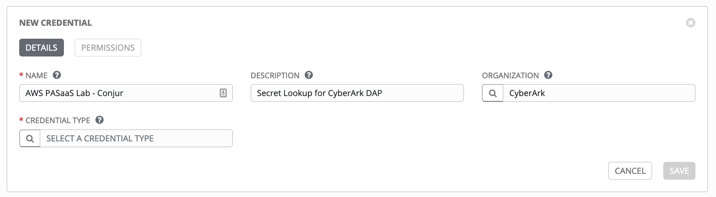
- Select the “CyberArk Conjur Secret Lookup” credential type.
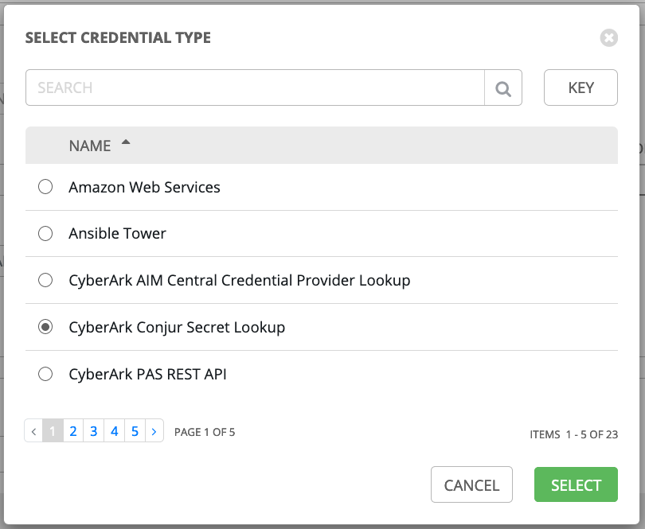
- Under Type Details, complete the following text fields:
  - Conjur URL
    - URL to DAP instance.
  - API Key
    - Ansible Tower’s host identity API Key created in DAP.
    - After the Credential is saved, this value will be encrypted and will not be allowed to be viewed by anyone again.
  - Account
    - DAP account name.
  - Username
    - Ansible Tower’s host identity created in DAP.
    - Must be prefixed with host/.
  - Public Key Certificate
    - The public SSL certificate contents for DAP.
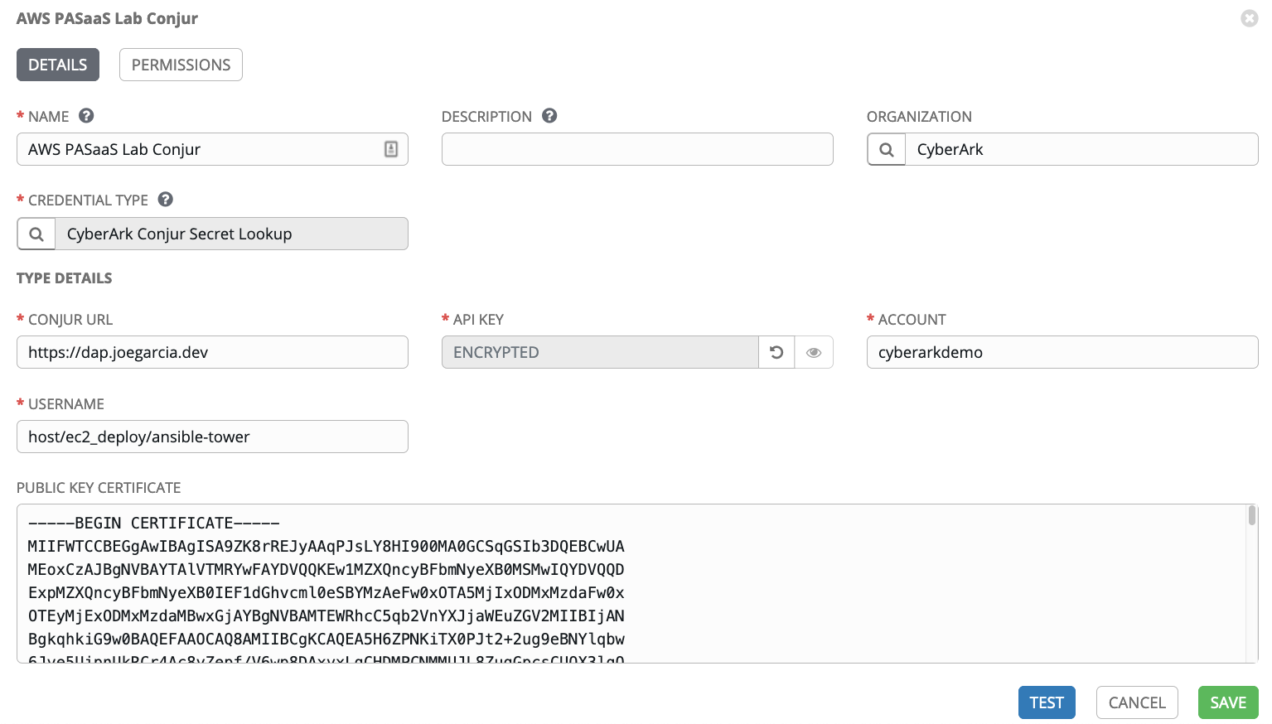

Testing the CyberArk Conjur Secret Lookup
- While viewing the Credential for CyberArk Conjur Secret Lookup in Ansible Tower, click the blue Test button next to Cancel and Save.
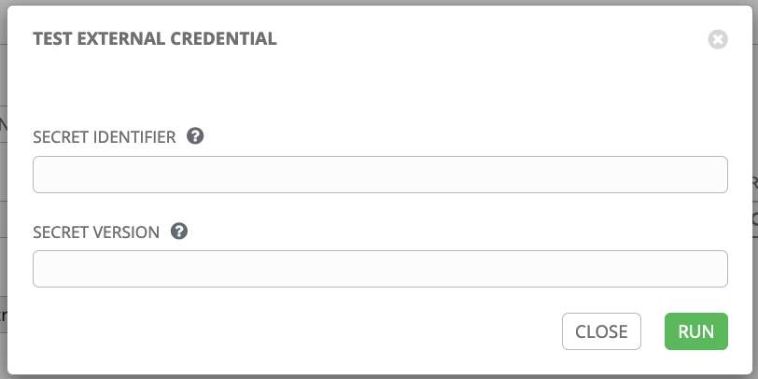
- In the Secret Identifier text field, add the path to the secret variable as it is in DAP. Optionally, you can include a version of the secret to return. Default is to return the latest version.
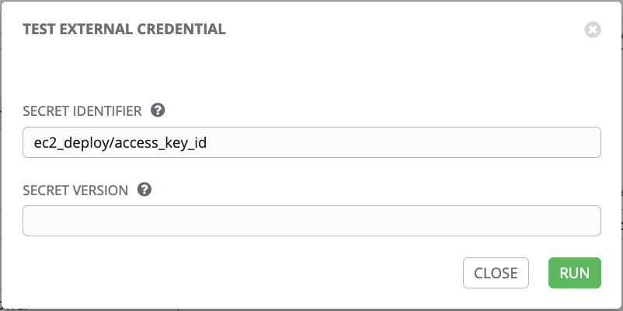
- Click Run and you will receive a toast alert as to the Success or Failure of the test.

Creating a new credential retrieved from CyberArk DAP
- Create a new credential that you would like to be retrieved from CyberArk DAP.
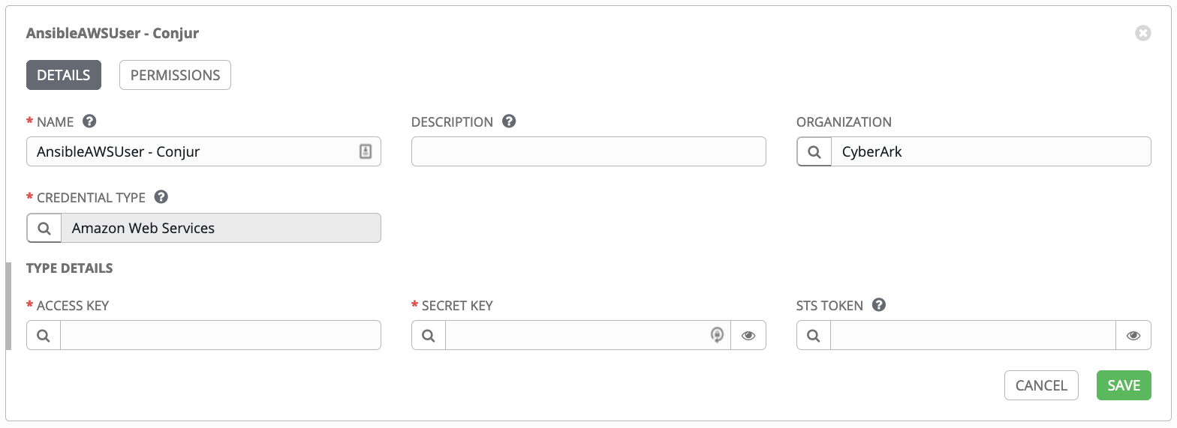
- Click the icon to the left of the text field which should contain the value of the DAP secret variable.
- Select the name for your CyberArk Conjur Secret Lookup and click Next.
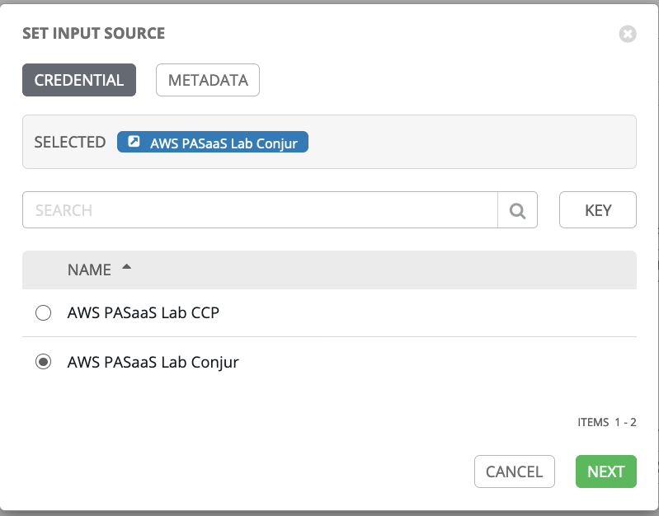
- In the Secret Identifier text field, add the path to the secret variable as it is in DAP. Optionally, you can include a version of the secret to return. Default is to return the latest version.
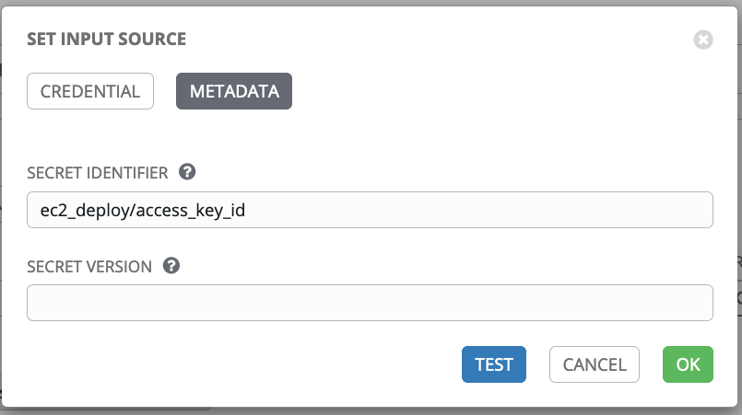
- Before saving, click the blue Test button to make sure the secret can be retrieved properly.
- If the test passed, click Save.

